Experiment No. 4

Aim: To study, design and implement practical applications of various encoders and decoders.

# Objectives:

1. To study different types encoders.
2. To study different types of decoders.
3. To design and implement practical applications of encoders and decoders.
4. To select appropriate encoders / decoder module for a specific applications.

# Equipment:

IC’s, regulated power supply, bread board, connecting wires, LED, DMM

# Theory:

## Encoder

An encoder is a device, circuit, transducer, software program, algorithm or person that converts information from one format or code to another. The purpose of encoder is standardization, speed, secrecy, security, or saving space by shrinking size. Encoders are combinational logic circuits and they are exactly opposite of decoders. They accept one or more inputs and generate a multibit output code.

Encoders perform exactly reverse operation than decoder. An encoder has M input and N output lines. Out of M input lines only one is activated at a time and produces equivalent code on output N lines. If a device output code has fewer bits than the input code has, the device is usually called an encoder.

## Octal to binary encoder:

Octal-to-Binary take 8 inputs and provides 3 outputs, thus doing the opposite of what the 3-to-8 decoder does. At any one time, only one input line has a value of 1. The Table 1 below shows the truth table of an Octal-to-binary encoder and Figure 1 shows Logic Diagram of octal to binary encoder.

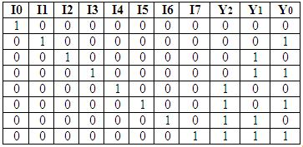

Table 1: Truth Table of octal to binary encoder

 For an 8-to-3 binary encoder with inputs I0-I7 the logic expressions of the outputs

Y0 - Y2 are:

Y0 = I1 + I3 + I5 + I7

Y1= I2 + I3 + I6 + I7

Y2 = I4 + I5 + I6 +I7

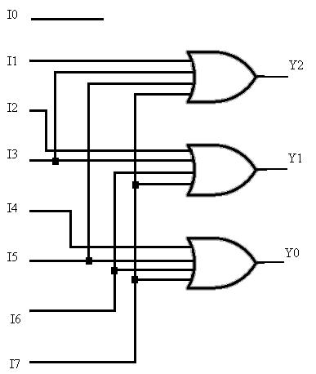

Fig 1: Logic Diagram of octal to binary encoder

## Priority encoder

A priority encoder is a circuit or algorithm that compresses multiple binary inputs into a smaller number of outputs. The output of a priority encoder is the binary representation of the ordinal number starting from zero of the most significant input bit. They are often used to control interrupt requests by acting on the highest priority request. It includes priority function. If 2 or more inputs are equal to 1 at the same time, the input having the highest priority will take precedence. Internal hardware will check this condition and priority is set. The Table 2 below shows the truth table of Truth Table of 4 bit priority encoder and Figure 1 shows Logic Diagram of 4 bit priority encoder.

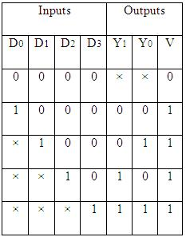

Table 2: Truth Table of 4 bit priority encoder

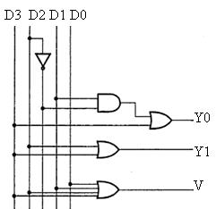

Fig 2: Logic Diagram of 4 bit priority encoder

 IC 74148 is an 8-input priority encoder. 74147 is 10:4 priority encoder

## Decoder

In digital electronics, a decoder can take the form of a multiple-input, multiple-output logic circuit that converts coded inputs into coded outputs, where the input and output codes are different e.g. n-to-2n , binary-coded decimal decoders. Decoding is necessary in applications such as data multiplexing, 7 segment display and memory address decoding.

The example decoder circuit would be an AND gate because the output of an AND gate is "High" (1) only when all its inputs are "High." Such output is called as "active High output". If instead of AND gate, the NAND gate is connected the output will be "Low" (0) only when all its inputs are "High". Such output is called as "active low output".

A slightly more complex decoder would be the n-to-2n type binary decoders. These types of decoders are combinational circuits that convert binary information from 'n' coded inputs to a maximum of 2n unique outputs. In case the 'n' bit coded information has unused bit combinations, the decoder may have less than 2n outputs. 2-to-4 decoder, 3-to-8 decoder or 4-to-16 decoder are other examples.

The input to a decoder is parallel binary number and it is used to detect the presence of a particular binary number at the input. The output indicates presence or absence of specific number at the decoder input.

Let us suppose that a logic network has 2 inputs A and B. They will give rise to 4 states A, A’, B, B’. Table 3 shows truth table for 2:4 decoder and Figure 3 shows logic diagram for 2:4 decoder.

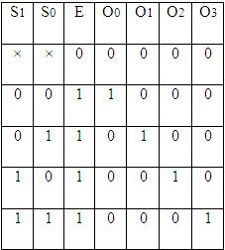

Table 3: Truth Table of 2:4 decoder

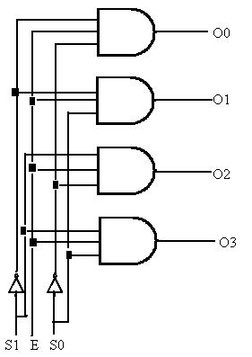

Fig 3: Logic Diagram of 2:4 decoder

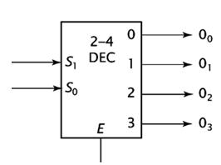

Fig 4: Representation of 2:4 decoder

For any input combination only one of the outputs is low and all others are high. The low value at the output represents the state of the input. Figure 4 shows symbolic representation of 2:4 decoder.

## Decoder expansion

Combine two or more small decoders with enable inputs to form a larger decoder e.g. 3-to-8-line decoder constructed from two 2-to-4-line decoders.

Decoder with enable input can function as demultiplexer.

## 3:8 decoder

It uses all AND gates, and therefore, the outputs are active- high. For active- low outputs, NAND gates are used. It has 3 input lines and 8 output lines. It is also called as binary to octal decoder it takes a 3-bit binary input code and activates one of the 8(octal) outputs corresponding to that code. The truth table is shown in Table 4 and logic diagram is shown in Figure 5.

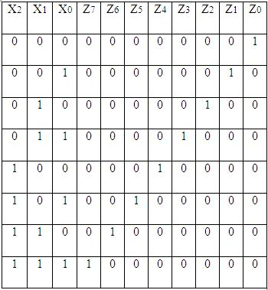

Table 4: Truth Table of 3:8 decoder

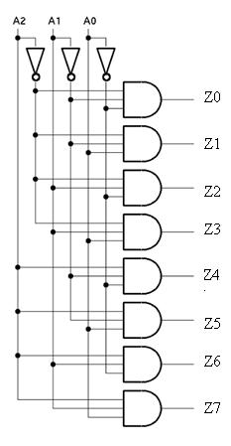

Fig 5: Logic Diagram of 3:8 decoder

# Procedure:

1. Connect the components as shown in the circuit diagram.
2. Give +5V supply to the IC’s.
3. From the LED observe the outputs.
4. Make a note of the truth tables in the observations.
5. Verify the truth tables accordingly.

# Design:

## Octal to binary

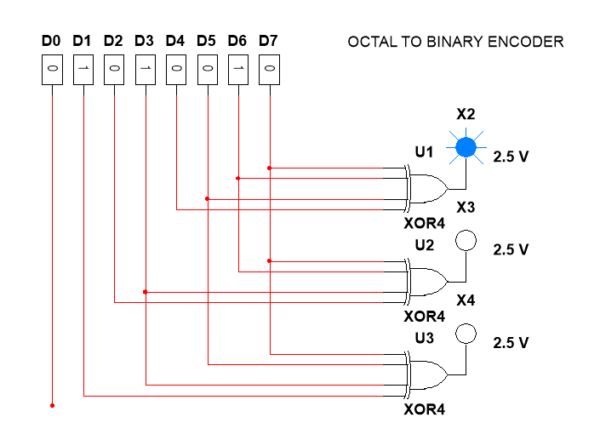

## PRIORITY ENCODER

8bit priority encoder

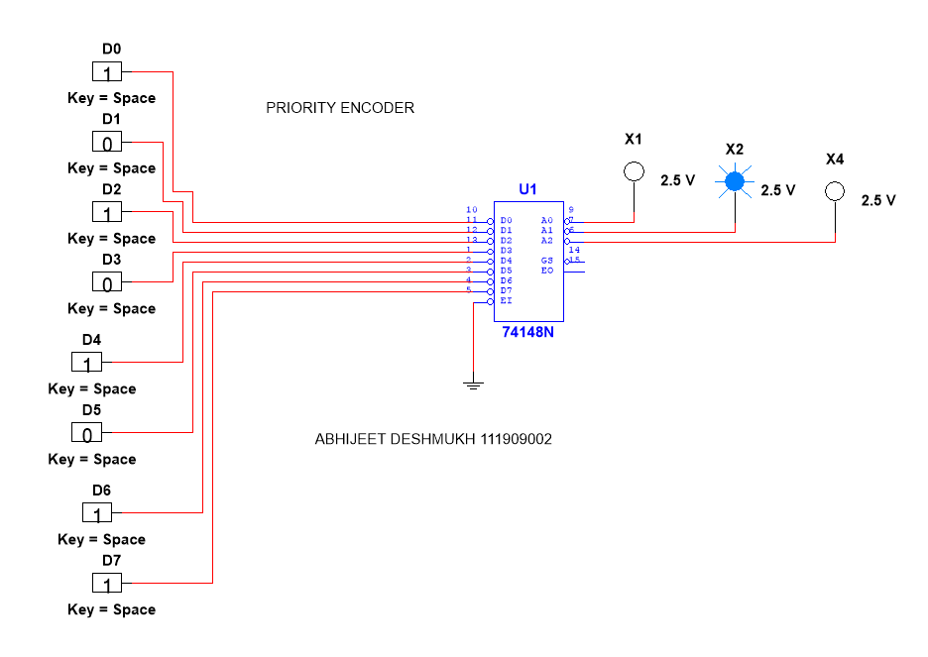

4bit priority encoder

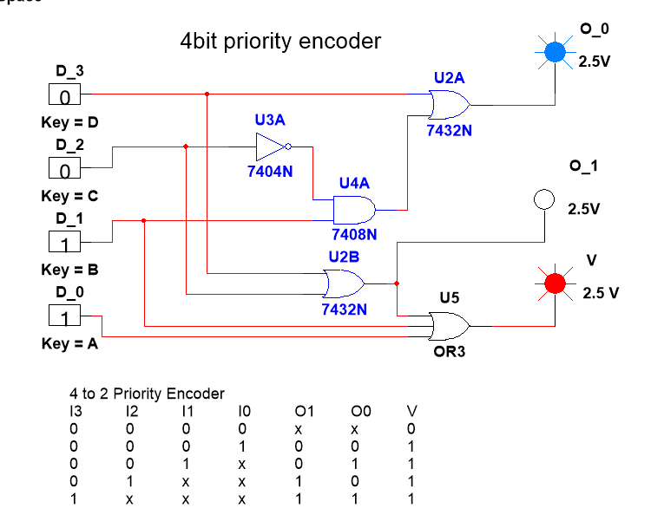

## 2 to 4 Decoder

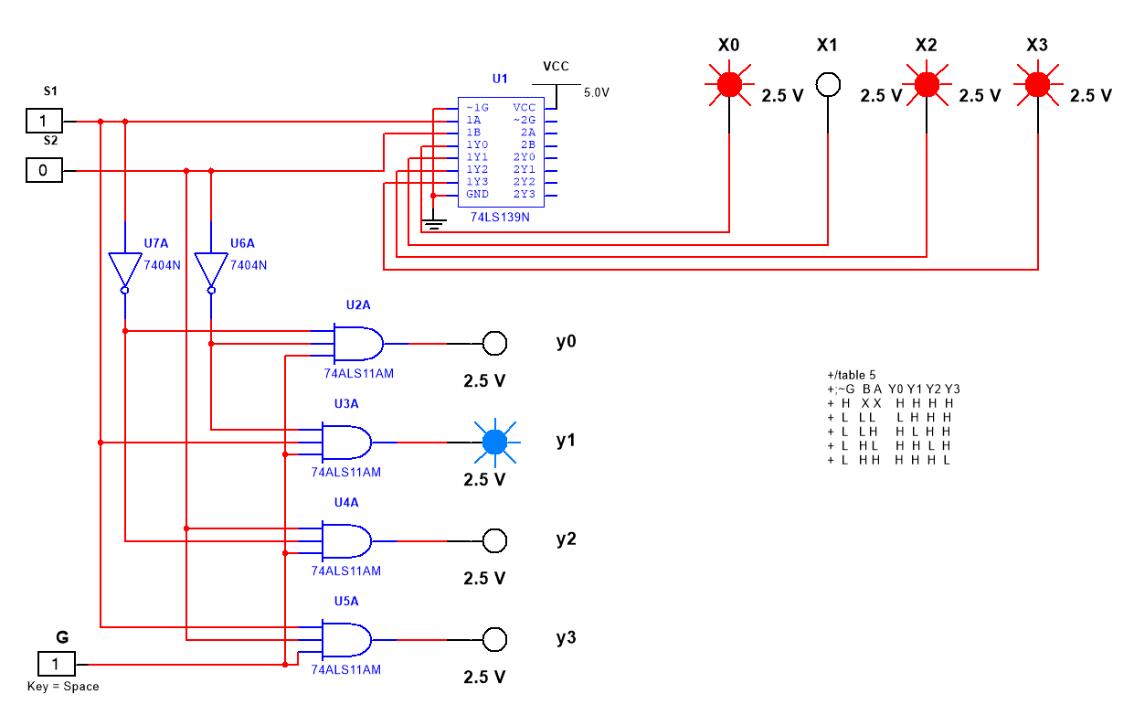

## 3 to 8 Decoder

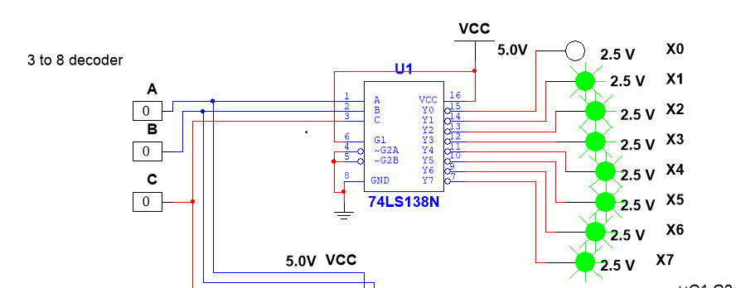

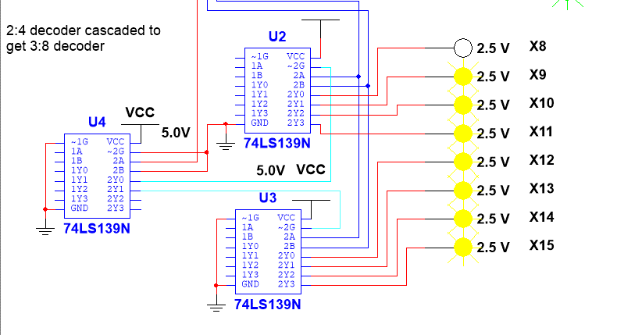

# Observations:

## Octal to binary encoder

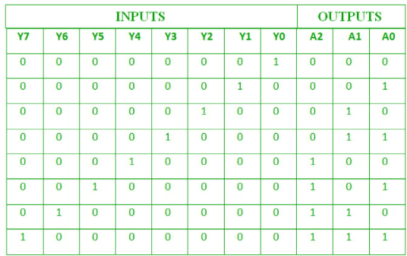

## priority encoder

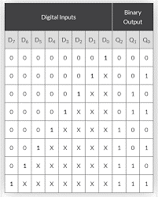

## 2 to 4 Decoder

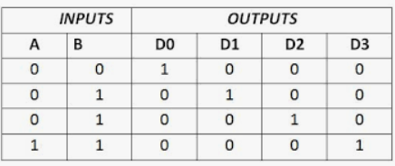

## 3 to 8 Decoder

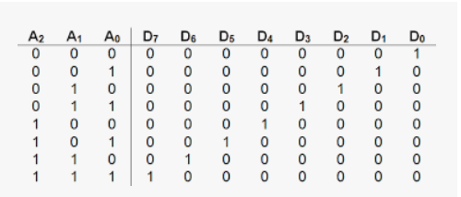

# Result:

Above mentioned circuits were created and run in multisim software**.**

# Conclusion:

Truth tables were verified by simulating the created circuit.

# What did you learn?

I learnt how octal to binary encoder, 2 to 4 and 3 to 8 decoders circuits are made, and I understood their working by simulating them and verifying the truth table,

**Cascading of decoders is also possible.**

**Assignment:**